COMP 1168 Final Project:

ABC Library Database

CRN-46705-201702

# Group 13:

## Andrew Cobb

101142044

## Arsalan Farooqui

101144384

## Giuseppe Ragusa

101109502

## Amarjit Sidhu

101134771

Conceptual Model:

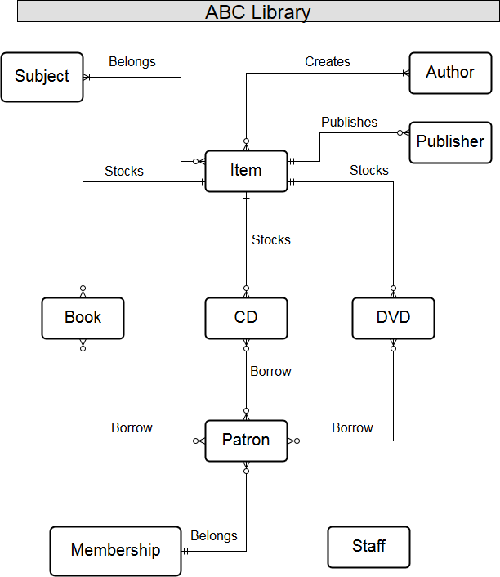

Physical Model:

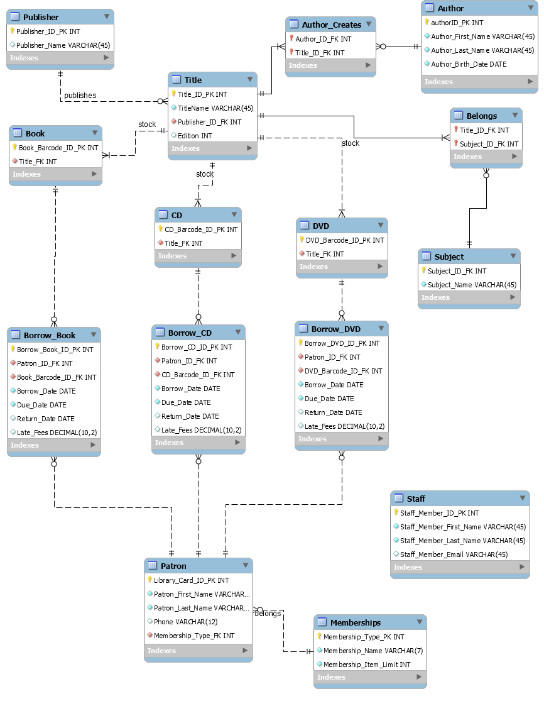

Assumptions

There may be publishers and authors who have no titles in the database. This allows information on authors and publishers to be stored even if the library removed or has not yet acquired their title. It would also help users looking for common authors or publishers to confirm that there are no titles associated with them in the Database.

There may be memberships that do not have any Patron’s, this allows for the addition of new membership types to be created without the need to first sign someone up for them.

Each title cannot have multiple publishers. A Title can have multiple authors.

Membership was created as its on table as opposed to a column in Patron’s tables for 3rd level normalisation. Data applied to due dates, etc. was reliant on the membership type.

For all Title’s that can be borrowed, we implemented a zero to many relationship as there may be new Title’s that have not yet been borrowed.

For Patron’s, we implemented a zero to many relationship as there may be new Patron’s that have not yet borrowed.

A Title may have multiple subjects but must have at least one to facilitate searches. There may be new subject added to the data base without being associated to a Title, or the library may stop stocking Title’s in a subject but subject will still exist in database.

All Title’s may have multiple editions, not just books, therefore an edition column was added to Title table.

Publisher and Authors may change with different editions of a Title.

Barcodes are integers and not alpha numeric for clarities sake.

­­­­­­

Staff are unrelated to anything in this model, if a library staff member was to also be a patron they would be treated as a separate entity, and we do not need to record data on which staff facilitated each transaction.

Appendix

# SQL Queries

USE projschema;

-- Query 1

SELECT * FROM projschema.title WHERE edition = 2;

-- */

-- Query 2

SELECT CONCAT(P.Patron_First_Name," ", P.Patron_Last_Name) AS Patron_Name , M.Membership_Name

FROM Patron P NATURAL JOIN Memberships M;

-- */

-- Query 3

SELECT * FROM projschema.publisher p, projschema.title t, projschema.book b, projschema.borrow_book bb

WHERE p.Publisher_ID_PK = t.Publisher_ID_FK

AND t.Title_ID_PK = b.Title_FK

AND b.Book_Barcode_ID_PK = bb.Book_Barcode_ID_FK;

-- */

-- Query 4

SELECT count(*) FROM borrow_dvd

where (

return_date>due_date

);

-- */

-- Query 5

SELECT * FROM title ORDER BY Publisher_ID_FK;

-- */

-- Query 6

SELECT Borrow_DVD_ID_PK, Patron_ID_FK, DVD_Barcode_ID_FK, Borrow_Date

FROM borrow_dvd

WHERE (datediff(Return_Date,Borrow_Date))>4

GROUP BY Patron_ID_FK

HAVING Borrow_date > "2018-02-05"

ORDER BY Borrow_DVD_ID_PK;

-- */

-- Query 7

CREATE VIEW Authors_and_Titles AS SELECT

t.TitleName, ac.Title_ID_FK, ac.Author_ID_FK, a.Author_First_Name, a.Author_Last_Name

FROM projschema.title t, projschema.author a, projschema.author_creates ac

WHERE t.Title_ID_PK = ac.Title_ID_FK

AND ac.Author_ID_FK = a.authorID_PK;

-- */

-- Query 8

SELECT Patron_ID_FK, Borrow_Book_ID_PK, Late_Fees

FROM Borrow_Book B LEFT OUTER Join Patron P

ON B.Patron_ID_FK = P.Library_Card_ID_PK

ORDER BY Patron_ID_FK;

-- */

-- Query 9

SELECT Patron_First_Name, Patron_Last_Name FROM patron

WHERE Library_Card_ID_PK IN

(SELECT Patron_ID_FK FROM borrow_book

WHERE Late_Fees > 0);

-- */

-- Query 10

SELECT DISTINCT B1.Patron_ID_FK, B1.Borrow_CD_ID_PK, B1.CD_Barcode_ID_FK

FROM Borrow_CD B1 JOIN Borrow_CD B2

ON B1.Patron_ID_FK = B2.Patron_ID_FK AND

B1.Borrow_CD_ID_PK = B2.Borrow_CD_ID_PK AND

B1.CD_Barcode_ID_FK = B2.CD_Barcode_ID_FK

ORDER BY B1.Patron_ID_FK

-- */